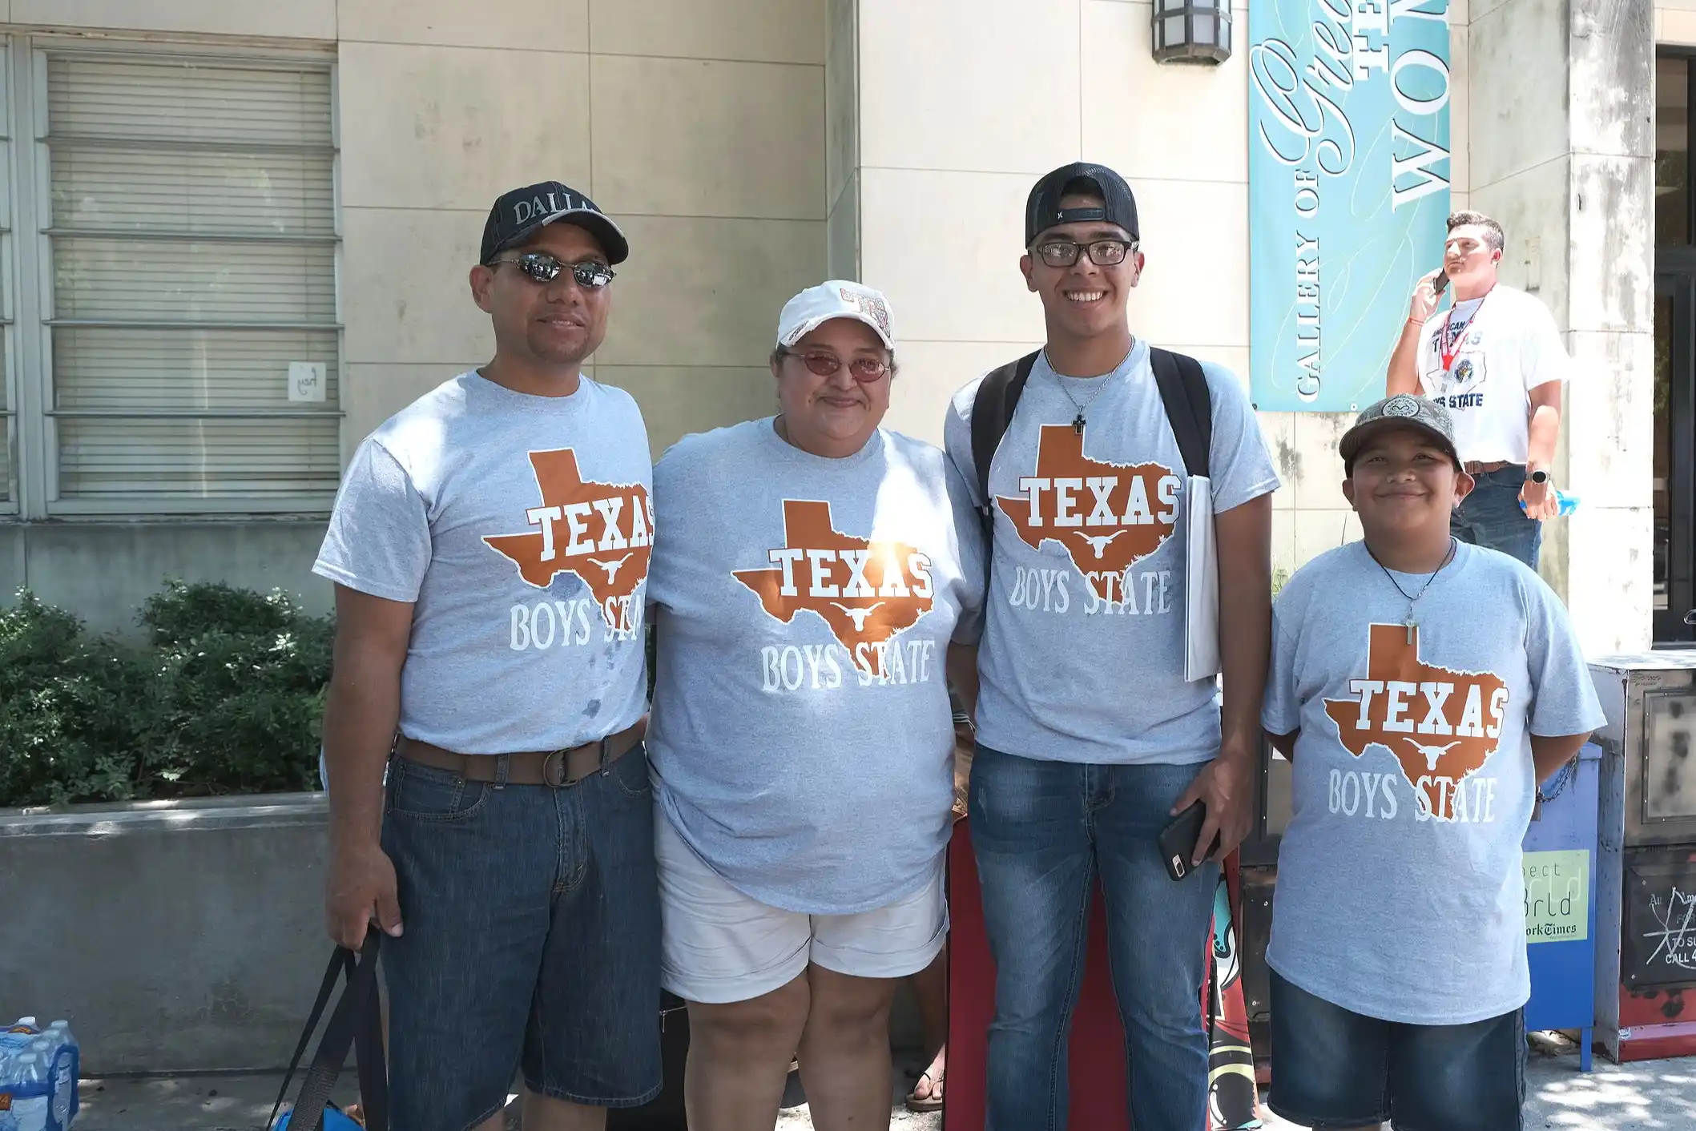




The American Legion
Department of Texas
Strategic Long Range Plan
2026
2030

19 January 2024
Draft Plan, Ver. 1
Version 6 (25 September 2026)

Index

Items Page(s)
Purpose 3

Desired Endstate, Mission, Vision, Priorities, Core Values 3 - 4

Goals 5

Lines of Effort (LOE – Includes Means & Objectives) 5 - 7

Additional Objectives to Consider for Support of LOEs 7

Measurable Data Questions 8 - 9

Measurable Data Report (Draft Template) 10

Definitions/Acronyms 11

Organizational Chart of Strategic Long Range Planning Committee 12

Annual Virtual Meeting Timelines 13

Annual Action Plan Template 14 – 15

Improvement Submission Form (Template) 16 - 17

The American Legion of Texas Strategic Plan, “Train the Trainer” Briefing Enclosure A

Version #6
25 September 2026

Purpose

Service to our veterans, their families and their communities is as solid a plan today, in a period of epoch-making change, as it was in 1919 when the founding fathers of The American Legion met in Paris.

They were true visionaries. Much of The American Legion’s success rests on its understanding that the fight for veteran’s rights - past, present or future - is never-ending. While our purposes may remain unchanged, our capabilities must not. The environment is changing; we must stay in front of that change to be the nation’s advocate for veterans.

For success we must continue to provide first-rate service to our veterans in the 21st century. The basis for this blueprint is the Preamble to the Constitution of The American Legion which was finalized at the St. Louis caucus in 1919 and reaffirmed at Minneapolis in 1994. This declaration reaffirmed the principles on which our great organization was developed.

And the method for applying this blueprint for success to American Legion activities has not changed either. Personal contact at every level of leadership within The American Legion is the catalyst that has made us successful in the past and will make us successful in the future.

Since our founding fathers gave us a sound, clear focus, we need to build on this direction as we seek every opportunity to excel in growth and membership in the next century.

The purpose of this plan is to provide the appropriate guidelines for a continuity of effort throughout the Department of Texas, at every level, to ensure that meaningful objectives are established, tracked, analyzed, and met, regardless of the inevitable changes in the leadership hierarchy.

This plan will articulate the Department’s Desired Endstate that includes the Department Mission, Vision, Priorities, Core Values, and Goals. It will not replace the Constitution & By-Laws at any level, but is intended to fully complement any existing, or future, documents that are directive in nature.

Desired Endstate

Provide first rate service to The American Legion members and families with support that serves their needs; promoting a better understanding of the principles of democracy; inculcating among all people a higher appreciation of the benefits of American citizenship; fulfilling our commitment to community, state and Nation; and providing appropriate guidelines for a continuum of effort throughout the Department of Texas to ensure meaningful objectives are established and met.

- Every level of the Department will adopt and follow the mission and vision statement.

- Every level of the Department will exemplify the ideals of The American Legion as set forth in the preamble.

- Every level of the Department will be a value-based organization, through annual or periodic self-evaluation techniques using as described in the Post Officers Guide.

- Division and District Commanders will take an active role in assisting Posts to maintain a current certification of Post Officers.

- Division and District Commanders will ensure all Texas Posts complete and submit annual reports as described in the Post Officers Guide.

Mission Statement

The American Legion’s mission statement, as adopted by the National Executive Committee in October 2020, is “To enhance the well-being of America’s veterans, their families, our military, and our communities by our devotion to mutual helpfulness.”
Vision Statement

The American Legion’s vision statement is “The American Legion: Veterans Strengthening America.”
Priorities

Focus on service to Veterans, Families, and to the community. Legion officers at every level will pave the way for Vision reinforcement.
Core Values
The American Legion’s Core Values are as follows:
A Veteran is a Veteran – which means The American Legion embraces all current and former members of the military and endeavors to help them transition into their communities.
Selfless Service – which means The American Legion celebrates all who contribute to something larger than themselves and inspires others to serve and strengthen America.
American Values and Patriotism – which means The American Legion advocates for upholding and defending the United States Constitution; equal justice and opportunity for everyone; and discrimination against no one individual. These values are nested within youth education, responsible citizenship, and honoring military service by observing and participating in memorial events.
Family and Community Engagement – which means The American Legion meets the unique needs of local communities.
Advancing the Vision – which means The American Legion educates, mentors and leads new generations of Americans.
Honor Those Who Came Before Us – which means The American Legion pays perpetual respect for all past military sacrifices to ensure they are never forgotten by new generations.
Goals

Goals – The Department, Divisions, Districts and every Post take the initiative to be proactive, growth oriented with informed, trained and knowledgeable members who understand and communicate the programs and principles of The American Legion to all eligible veterans, military personnel, family members, community and Post members. These Goals can be accomplished following five synchronized Lines of Effort (LOE) that enables The American Legion to collectively strive towards the Department’s desired Endstate:

LOE #1: Veterans Affairs & Rehabilitation - Respond to quality-of-life needs of all Veterans & their families
Objectives for Veterans Affairs & Rehabilitation
OBJ. 1-1: Expand Department VSO capacity
OBJ. 1-2: Improve VA&R information sharing with community and members
OBJ. 1-3: Expand or improve access to care for Veterans
OBJ. 1-4: Improve education programs on PACT Act and other health issues
OBJ. 1-5: Implement and/or coordinate for free lending closets for Veteran med equip.
Means for Veterans Affairs Rehabilitation
- VA Volunteer Services (VAVS);
- Buddy Check system; newsletters; mailings; VSO involvement; VA visits; Vets
Helping Vets; holiday meals.
- VA Disability Education Services; VSO Annual Joint Review.
- VA Disability Reviews; mobile healthcare clinic service.
- Second-hand equipment storage; community service Veteran support.

LOE #2: National Security: Maintain a strong National Defense
Objectives for National Security
OBJ. 2-1: Increase disaster preparedness assistance and education to Post members and
communities
OBJ. 2-2: Support national patriotic and emergency responder events
OBJ. 2-3: Establish positions on border security at state level and where applicable
OBJ. 2-4: Partner/expand collaboration with AD, USAR, NGB members & families
OBJ. 2-5: Establish a Post-level Legislative Committee
OBJ. 2-6: Institute a Community Relations Liaison/Director at all levels of the Legion

Means for National Security
- Increase membership and visibility of The Legion culture within the community
- Memorial Day flag ceremonies; 4th of July parades; Veterans Day events
- Awards program; Veteran & Military Family Sponsorship Program
- Become an extension of recruitment efforts for DoD and vice versa for the Legion
- Create a legislative writing program; institute legislative program management
- Veteran & Military Family Support; other national security programs
LOE #3: Americanism: Perpetuate the principles of government embodied in the U.S Constitution
Objectives for Americanism
OBJ. 3-1: Improve marketing and branding of The American Legion
OBJ. 3-2: Forge partnership with first responders and community educational
institutions
OBJ. 3-3: Showcase the American principle that interest of people is above
special interests
OBJ. 3-4: Increase Americanism Program participation
OBJ. 3-5: Combat all anti-American tendencies, activities and propaganda
OBJ. 3-6: Foster the teachings of Americanism in the community and schools

Means for Americanism
- Combat anti-American tendencies; institute "Writing 101" class for awards,
articles, resolutions
- Oratorical, Boys State, Youth Cadet Law Enforcement, and other Americanism
programs
- 4 Chaplains event; Veterans Day parades; enhance Vets in the Classroom Program - Patriotism Education; update contact information via phone calls, text, emails - Sunset Legacy Scholarship donations and replace with Veterans and Children’s
Foundation
- School visits/programs, ALR burials/escort support; PACT Act educ.; VA visits

LOE #4: Children & Youth: Prepare each generation to meet its citizenship obligation
Objectives for Children & Youth
OBJ. 4-1: Expand scouting membership and participation
OBJ. 4-2: Educate and embrace children and youth opportunities
OBJ. 4-3: Educate and utilize Temporary Financial Assistance program
OBJ. 4-4: Educate and increase involvement with child safety

Means for Children & Youth
- Expand community Outreach efforts with High Schools like improvements with
Scouting
- Supporting VCF, CWF, and other children and youth programs
- Collaboration with VA and/or community businesses, to include Veteran donations
- VSO external training
- Youth/high school Shooting Programs
- Participate and support “School Night Out”

LOE #5: Business Operations & Membership: Be a valued-based organization committed to serving God, Country, Community and every Veteran

Objectives for Business Operations & Membership
OBJ. 5-1: Accountability: Institute fiscal responsibility and general accountability to
maintain a viable Legion at all levels
OBJ. 5-2: Training: Basic Training Course for new members and Train the Trainer
program for other members
OBJ. 5-3: Communication: Improve/update strategic communication platforms at all
levels
OBJ. 5-4: Growth: Use Post Revitalizations to incorporate feasible 5-year
Membership Plans and create strategic plan elements like mission, vision, goals,
and priorities

Means for Business Operations & Membership
- Maintain/improve required reports on TXLegion.org
- Department Fundraisers; Convention Management/Expectations
- Establish a Strategic Long Range training battle rhythm for all levels of the
Department; Provide leadership opportunities
- Department Legion College; Communication Plans
- Make “mentorship” a hallmark program among Post members, community, and
families
- Establish a 5-year membership plan and track progress; embrace the various elements
of a strategic plan
- Account for all 990’s and other financial paperwork

Additional Objectives to Consider in Support of LOEs

- Analysis of Measurable Data: Educate Commanders on how to interpret measurable data that is tied to the Strategic Long Range Plan in order to improve programs and processes. This will provide a means of creating and measuring short, intermediate, and long range goals to ensure everyone is focused on the LOEs, Objectives, goals, and the overall endstate within the Texas Strategic Plan.

- Automated Lessons Learned: Create a Post-level Lessons Learned database to capture great practices throughout Texas.

- Measures of Success: Develop new or improved sets of metrics for all levels of The American Legion to emphasize those areas that have the greatest impact on the success of the Department. Categorize the areas as immediate, short range, or long range; conduct or create necessary internal training to ensure that the concepts of change are fully embraced.

- Build the Bench: Create a mentorship & training program to help generate more leaders among Post populations.

- Continuity Files: Aggressively push the concept of developing and distributing “Continuity Files” prior to annual Post, District, and Division-level Installations. Necessary guidelines for continuity from one administration to another are crucial to further success at every level within the Department of Texas.

- Fiscal Responsibility: Ensure fiscal responsibility is exercised at all levels of The American Legion, and that assistance is made available in the areas of budgeting, accountability, internal review, expense control, reporting, fundraising, or any other area as requested.

- Standardized Data Management: Create a knowledge management program at the different levels of The American Legion and create measures for immediate, short and long term actions/change.

Measurable Data Questions
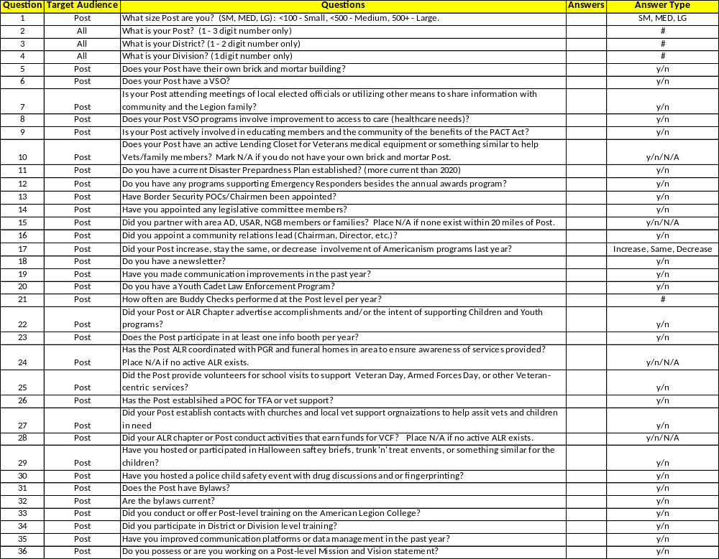

Measurable Data Questions
(Continued)
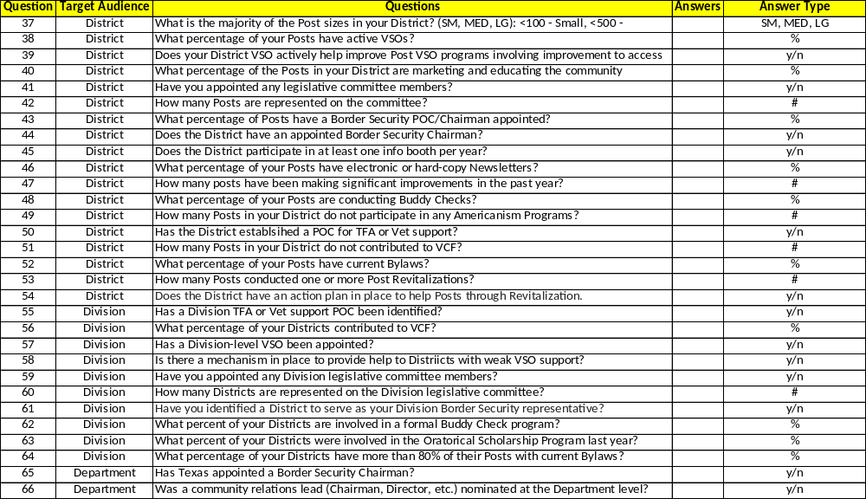

Measurable Data Report

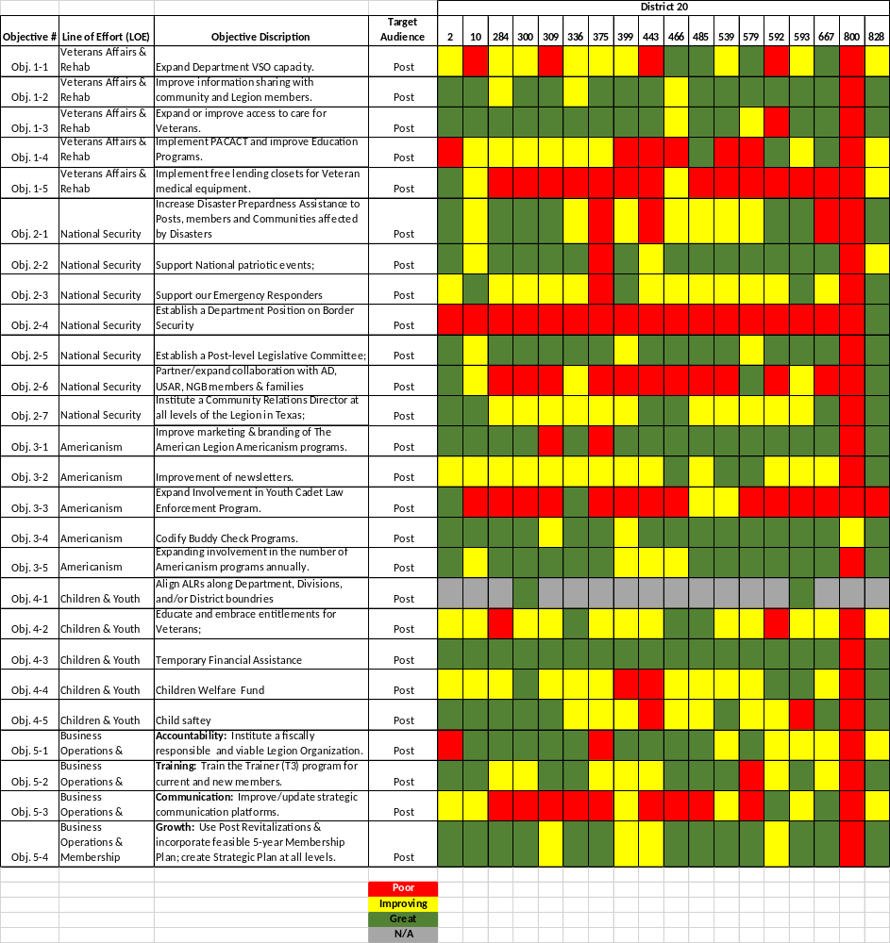
Example
Template

Lines of Effort Objectives on the above slide have a few
changes that are not captured on this measurement template.

Definitions/Acronyms
Definitions

- LOE Definition - Line of Effort towards a developed strategy that is a concentrated effort towards a desired endstate or outcome.
- Ends - Objectives toward which one strives to meet
- Means - Instruments or process/procedure by which some end can be achieved
- Measures - A quantifiable marker to determine if efforts are effective or efficient
- Ways - Courses of Action taken to meet objectives
- Stop Light Bubble Report - Summary report that indicates progress of measures as either RED (requires improvement), AMBER (status quo), or GREEN (Significant improvement made). Measures will help determine what parameters were set for each objective to meet a Red, Amber. Or Green status. This report is a snap-shot in time and updated quarterly, semi-annually, or annually.
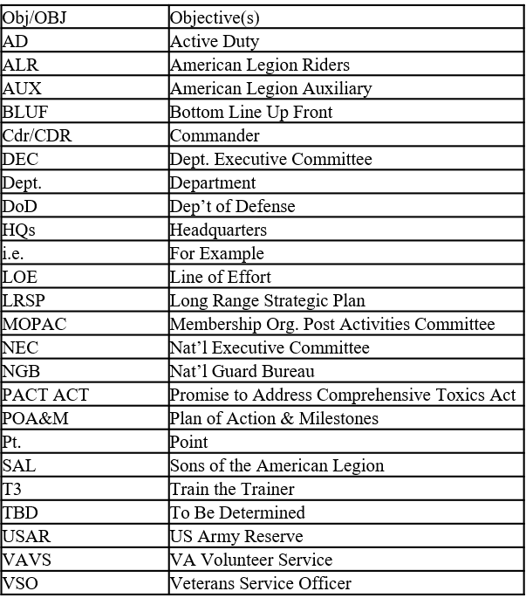

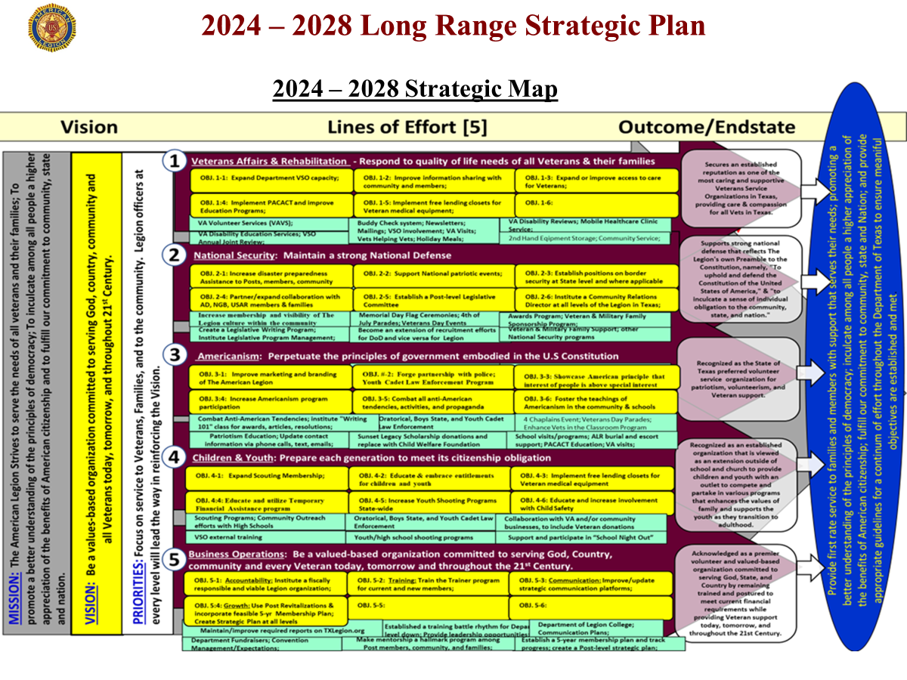
2026 – 2030 Strategic Map
LRSP Colors

- Maroon: Line of Effort
- Yellow: Objectives or Vision
- Green: Events/Actions/Items
- Blue: Endstate
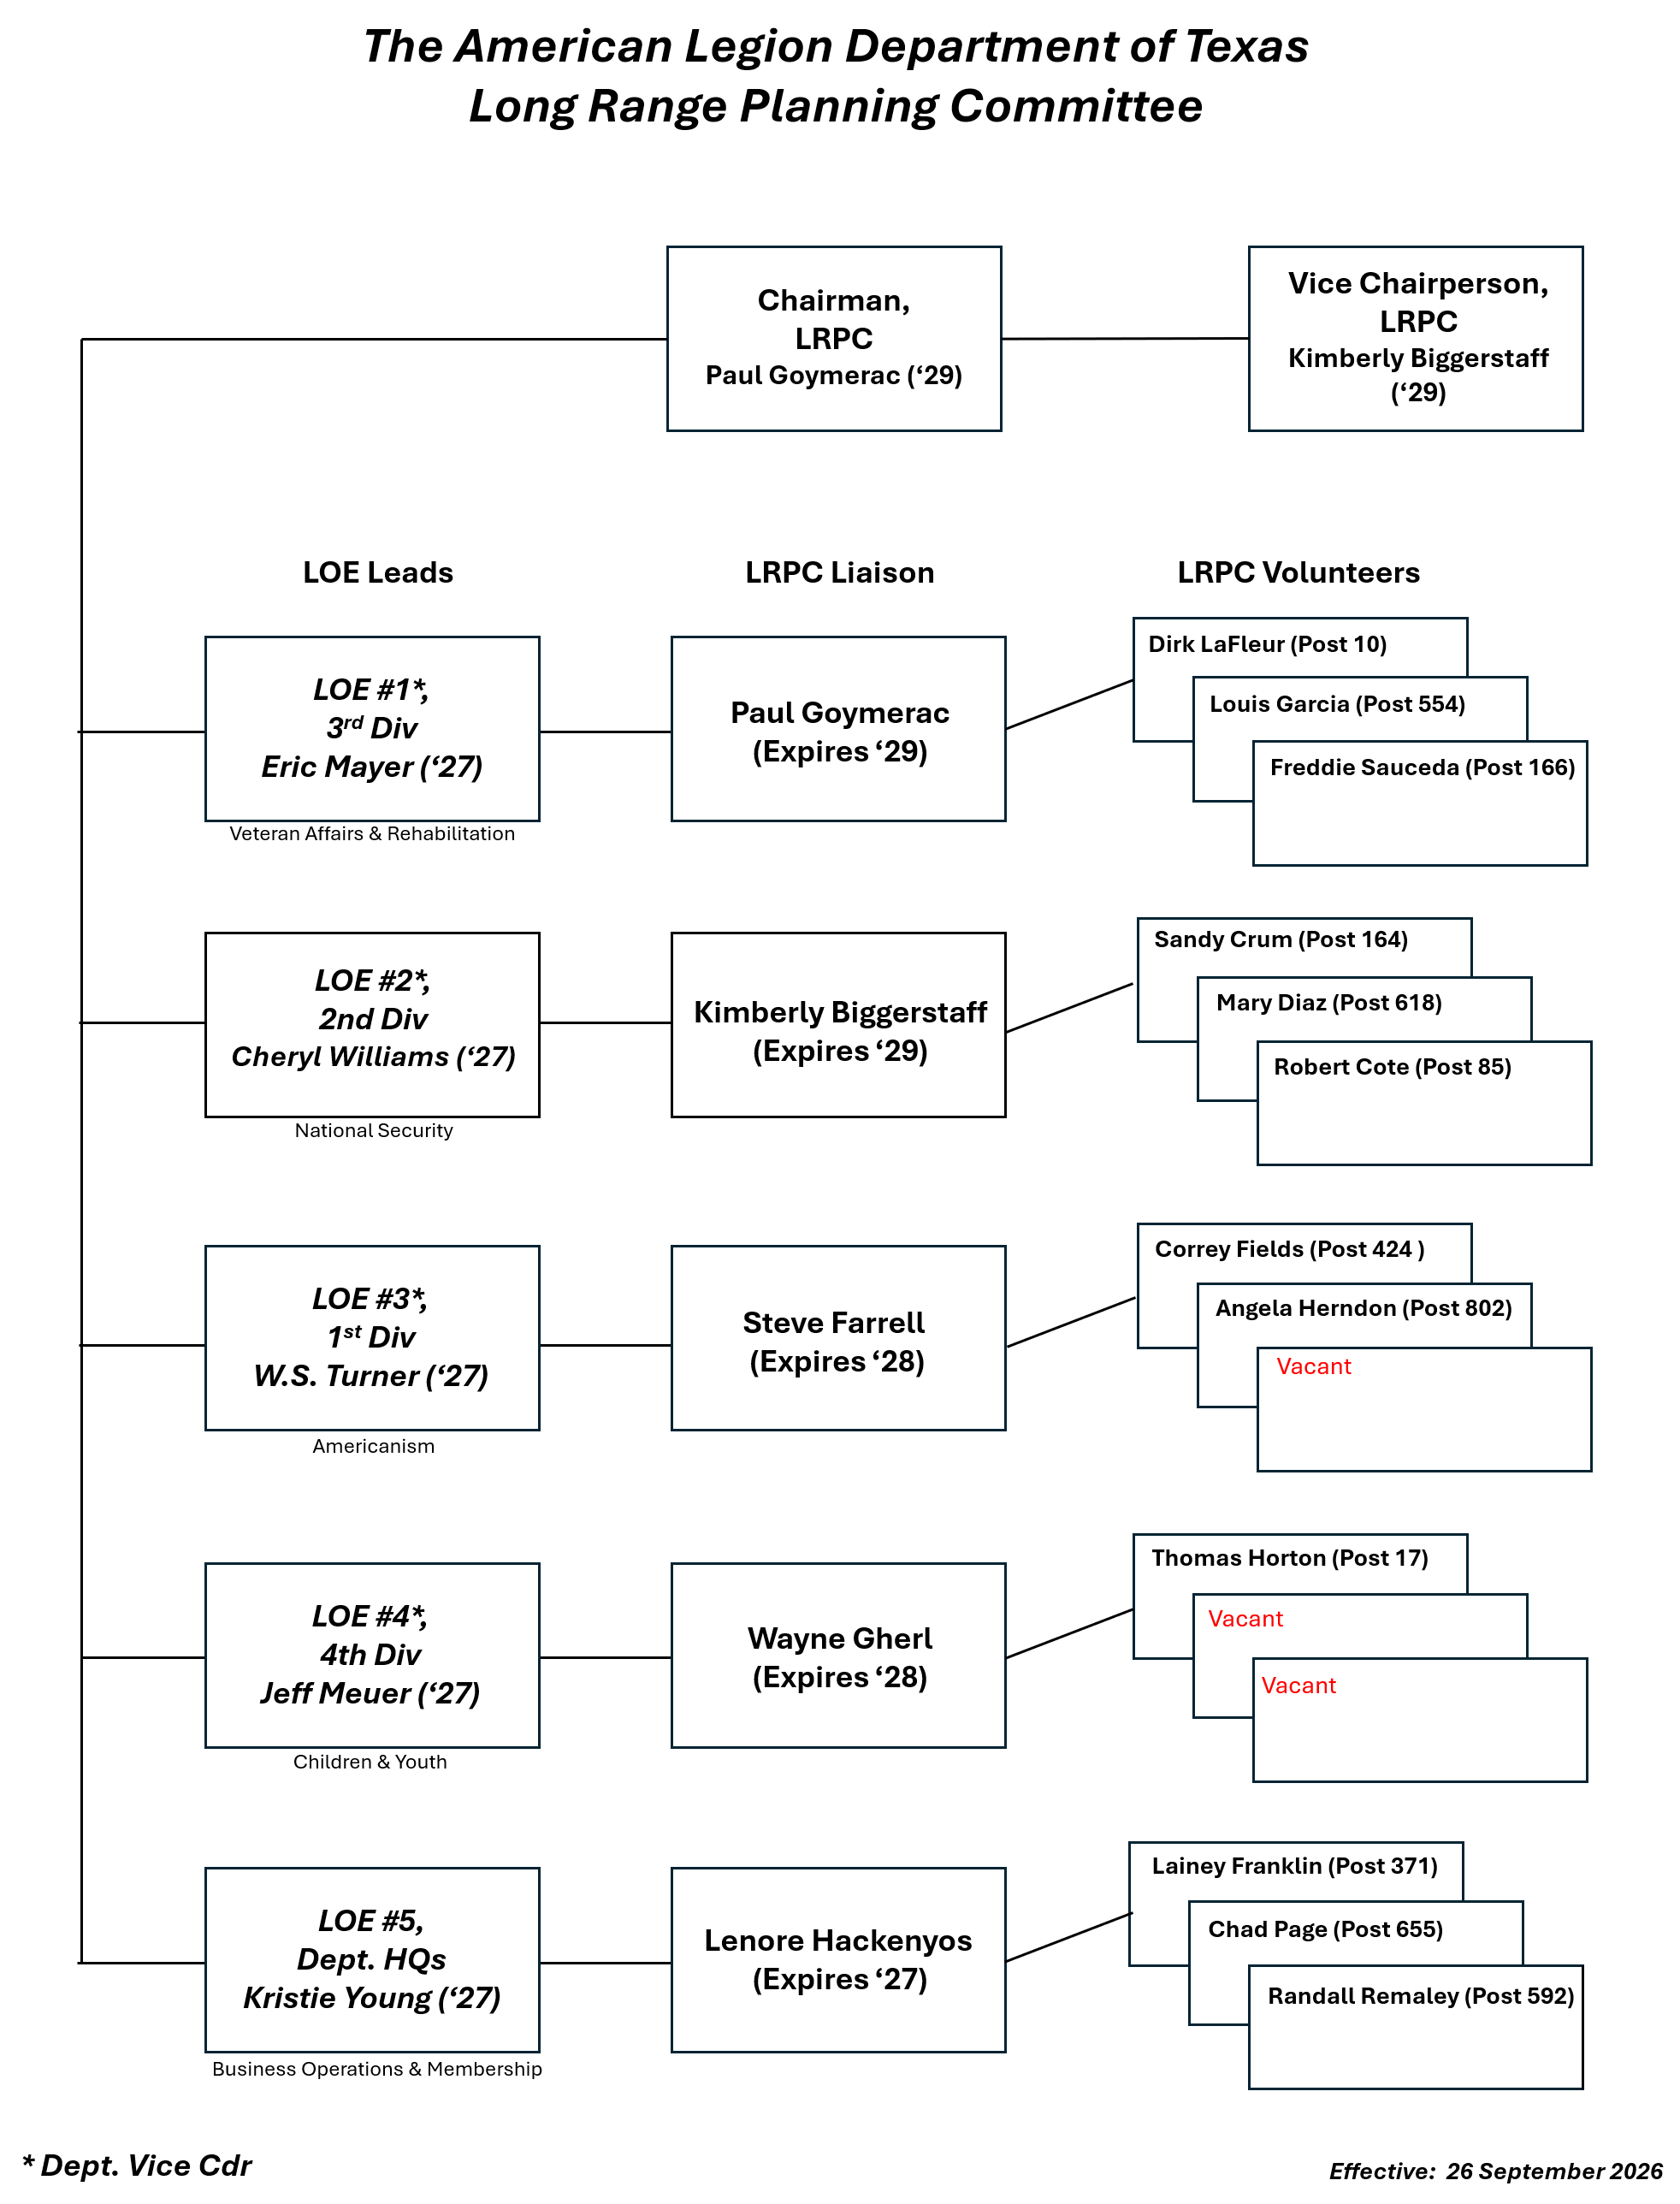

Annual Virtual Meeting Schedule
Date / Timeline | Meeting Type | Target Audience | Focus & Deliverable
July (At Convention)  Wed: 7 July ‘26 | In-Person Launch | Full Committee, DVCs, District Cmdrs | Hand-off LOE roles, issue the 1-Page Change Action Plan templates, and lock in these virtual dates and provide guidance/recommendation.
Sept. Fall DEC  Fri: 25 SEP ‘26 | Ad hoc individual in-person engagements | Attendees at Fall DEC | Create an updated Contact Roster and email current Strategic Plan and associated documents (Fall DEC session)
October (Mid-Month) Tue: 13 OCT ‘26 | Full Committee Sync | Full Committee, DVCs, District Cmdrs | Initial Zoom meeting to provide guidance, introduce key players, answer questions, and share input.
October (Mid-Month) Mon: 26 Oct ‘26  Tue: 27 Oct ‘26 | Sub-Committees; Working Group | 3-Person LOE Sub-Committees | Discuss possible objectives to concentrate on; help jump start the change process for each LOE; 5 separate Zoom meetings
November (Mid-Month) Tue: 24 Nov ‘26 | Full Committee Sync | Full Committee, DVCs, District Cmdrs | Review milestones. Focus on cross-LOE synchronization (e.g., aligning Media and Membership efforts).
December | No Formal Meetings | N/A | Operational Pause (Holiday/Post Events).
January (Mid-Winter Prep) Mon: 11 Jan ’27 Tue: 12 Jan ‘27 | Sub-committees; Review Mid-Winter Reports | 3-Person LOE Sub-Committees | Discuss and review draft Vice Cdr Reports that LRP Liaison prepared for their respective LOE. Each LOE; 5 separate Zoom meetings
January (At Mid-Winter) Sat: 23 Jan ‘27 | In-Person Mid-Point Review | Full Committee, DVCs, District Cmdrs | Deliverable: Submit formal Updates on existing Action Plans to the State Commander (Mid-winter Session).
February (Mid-Month)  Sun: 21 Feb ’27 Mon: 23 Feb ‘27 | Sub-Committee Kickoff | 3-Person LOE Sub-Committees | Adjust plans based on Mid-Winter feedback and begin spring push.
March (Mid-Month)  Sun: 21 Mar ‘27 | Full Committee Sync | Full Committee, DVCs, District Cmdrs | Review spring goals. Target underperforming Districts/Divisions for support.
April (Mid-Month) Mon: 19 Apr Tue: 20 Apr ‘27 | Sub-Committee Working | 3-Person LOE Sub-Committees | Focus on final execution steps for the current fiscal year's plans; reminder of Vice Cdr draft Reports
May (Mid-Month) Tue: 18 May ‘27 | Full Committee Sync | Full Committee, DVCs, District Cmdrs | Final push. Begin drafting the "New" Action Plans for the upcoming year.
6-11 July ’27 (At Convention) | In-Person Wrap-up & Reset | Full Committee, DVCs, District Cmdrs | Deliverable: Submit 1 "New" Action Plan and final results of the previous year's plan. Hand-off to incoming team.

Recommended Action Plan Template

📄 Department of Texas LRSP: Change Action Plan
Instructions: This document must be submitted to the LRSP Committee Chair or Vice Chair prior to the Texas Department Convention and Mid-Winter Conference. Focus should be placed on concrete actions, assigned personnel, and measurable outcomes. Do not submit conceptual ideas without an execution strategy.

PART 1: ADMINISTRATIVE DATA
- Line of Effort (LOE) __________________________________________________________

- Vice Commander Name: ______________________________________________________

- Committee Chair / Lead: ______________________________________________________

- Sub-Committee Members (3-Person Team): ___________________________________

- Submission Date: ___________________ Event: [ ] Summer [ ] Mid-Winter

- Plan Type: [ ] NEW Action Plan [ ] UPDATE to Existing Plan

PART 2: STRATEGIC FOCUS (The "Why")
1. Identified Issue, Gap, or Objective:
(Briefly describe the specific problem this plan solves or the strategic goal it achieves. e.g., "District 22 lacks a standardized disaster response protocol.")

2. Desired End-State:
(What does success look like in 6 to 12 months?)
(Also annotate if this action plan should be tracked as Short, Mid, or Long Range [<2 yrs., 2-5 yrs, >5]PART 3: EXECUTION STRATEGY (The "How")
3. Concrete Action Steps:
(List the exact steps your committee will take to solve the issue. No abstract concepts—only actionable tasks.)

- Action 1: __________________________________________________________________

- Action 2: __________________________________________________________________

- Action 3: __________________________________________________________________
4. Resource & Support Requirements:
(What do you need from the State Commander, District Commanders, or other Committees like Membership/Media to execute this?)

PART 4: MILESTONES & ACCOUNTABILITY (The "When & Who")
Identify the key tasks, who is specifically responsible, and the deadline. These items will be reviewed during the mandatory monthly/quarterly virtual synch meetings.
Core Milestone / Task | Owner (Name) | Target Date | Status (Pending/Active/Done)
1.
2.
3.
4.

Chair Signature: ___________________________ Date: ________________
State Commander / Vice Commander Approval:
Signature: ___________________________ Date: ________________

Improvement Submission Form (Template)

POC Name ___________________________________________________

POC Post Date __________________

Area Effected _________________________________________________

Recommended Change ___________________________________

_______________________________________________________
_______________________________________________________
_______________________________________________________
Rationale of Change ___________________________________

_______________________________________________________
_______________________________________________________
- Yes
Tied to a Resolution Res. # ___________________
- No

POC Email ___________________________________________________
POC Cell Number _____________________________________________
* Submit to Strategic Long Range Planning Committee Chairman; paul.goymerac@gmail.com
Improvement Submission Form (Continuation)

